Individual assignment 2
(Card Fraud Detection Model Report)

Name: AMAN BHATIA (2338152)
Institution Affiliation: UNIVERSITY CANADA WEST
Course: BUSI 652 PREDICTIVE ANALYTICS
Instructor: DR. MUHAMMAD HAMZA ASAD
Date: 22 FEB 2025

7th March 7, 2025
Introduction
Fraudulent credit card transaction detection is a critical task for banks to prevent monetary loss and customer mistrust. This report outlines machine learning model building and evaluation for fraudulent transaction detection from a dataset with attributes such as transaction distance, ratio of price, and transaction type. Specifically, the target variable is a binary variable indicating whether a transaction is fraud or not (fraud). Decision Trees, K-Nearest Neighbors (KNN), and linear regression (for experiment's sake only) are the three models that were trained and evaluated. Visualizations are added to the report to display information regarding data and model performance.
Dataset Overview
It entails:
• distance_from_home: It indicates how far from home settlement was done.
• distance_from_last_transaction: This is how far back the initial deal occurred.
• ratio_to_median_purchase_price: The median purchase price to transaction size ratio.
• repeat_retailer: Whether or not, transaction was conducted in the same store (0 or 1).
• used_chip: Whether a chip was used in the transaction.
• used_pin_number: Whether it involved a PIN
• Online_order: Whether it was an online order.
• fraud: Whether or not a transaction was fraudulent (0 or 1).
Data Preprocessing
Data Quality Resolution
The dataset is cleaned for missing and duplicate values. The dataset is clean and free to use in an analysis since there are no missing or duplicate values. All categorical variables are binary-encoded and do not need any further encoding.
Normalization Features
Three numerical features: distance_from_home, distance_from_last_transaction, and ratio_to_median_purchase_price, are standardized with StandardScaler, so that each feature is associated with the same contribution to model training.
Model Training
Three models are trained on the preprocessed data:
1. Decision Tree: A classification model in tree structure.
2. K-Nearest Neighbors (KNN): A classification algorithm that
3. Linear Regression: Experimentally used regression model for binary classification.
Model Evaluation
Evaluation Metrics
The models are assessed according to the following measures:
- Accuracy: Percentage of transactions classified correctly.
- Precision: The proportion of fraud transactions detected accurately to all fraud transactions that were predicted.
- Recall: Percentage of correctly detected fraud transactions out of total actual fraud transactions.
- F1-Score: Harmonic mean between recall and precision.
- Confusion Matrix: A graphical depiction of false/true positives and negatives.
Results
Decision Tree
• Accuracy: 0.999985
• Precision: 0.9999426671253296
• Recall: 0.9998853408243995
• F1-Score: 0.9999140031532178
KNN
• Accuracy: 0.998675
• Precision: 0.9931105752669652
• Recall: 0.9916872097689617
• F1-Score: 0.9923983821462379
Linear Regression
• Accuracy: 0.9216
• Precision: 0.7283087283087283
• Recall: 0.16121080089434156
• F1-Score: 0.26398798347728125

Model Tuning
Decision Tree
• Best Parameters: {'max_depth': 7, 'min_samples_split': 2}
• Tuned Accuracy: 0.999985
KNN
• Best Parameters: {'n_neighbors': 3}
• Tuned Accuracy: 0.99874
• Tuned Precision: 0.9931722990418268
• Tuned Recall: 0.9923751648225649
• Tuned F1-Score: 0.9927735719201651

Visualizations
Feature Importance (Decision Tree)
The Decision Tree model shows the most essential features among the models.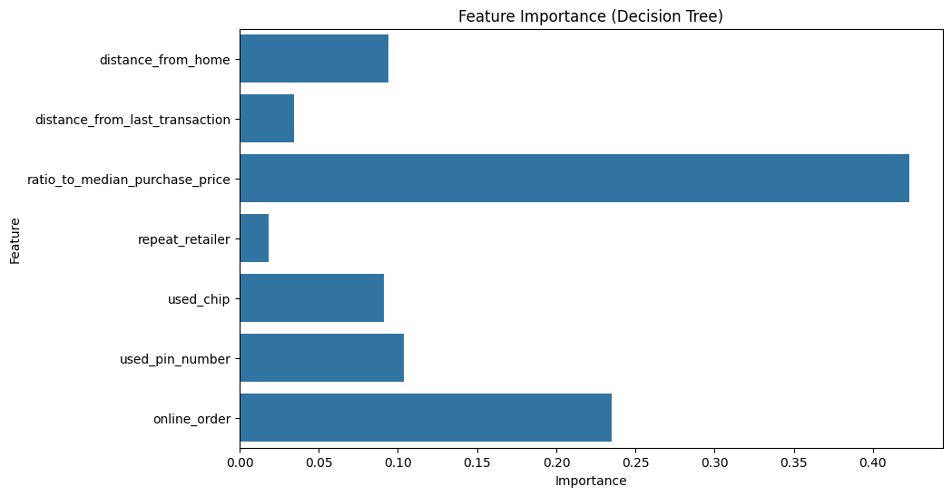
Fig 1.0: Feature Importance for Decision Tree

Confusion Matrix Heatmaps
Decision Tree
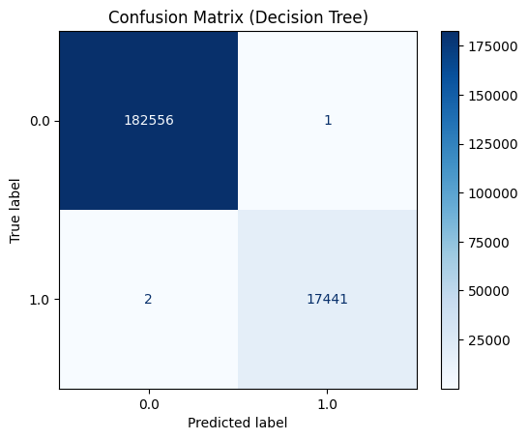
Fig 2.0: Decision Tree Heatmap
KNN
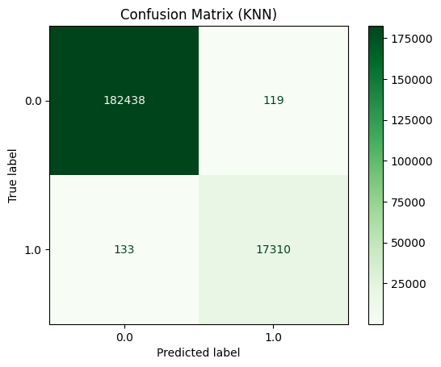
Fig 3.0: KNN Heatmap

Linear Regression
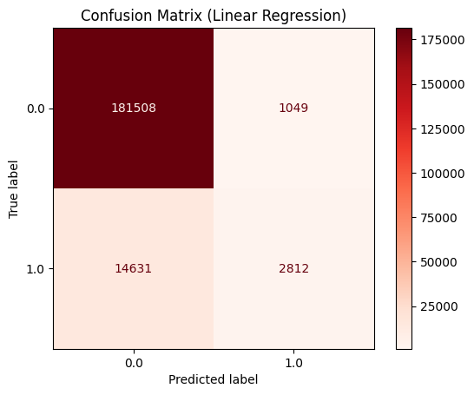
Fig 4.0: Linear Regression Heatmap
Precision-Recall Curves
It shows the different models with precision and recall trade off. Decision Tree and KNN outshines Linear Regression.
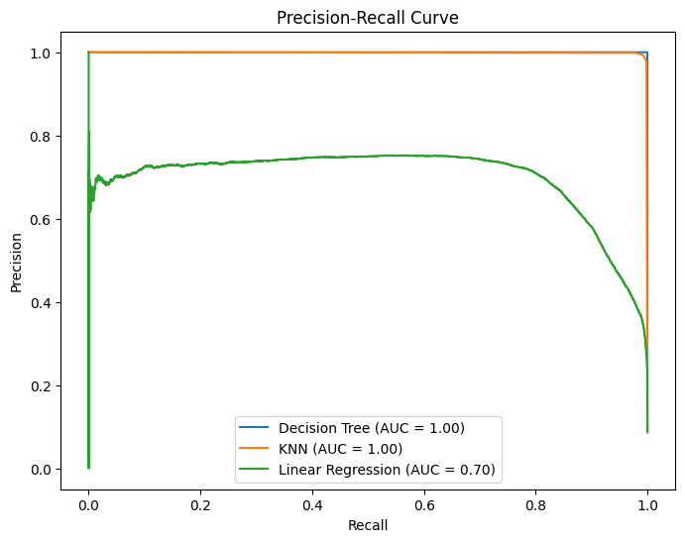
Fig 5.0: Precision-Recall Curves
Distribution of Predictions (Linear Regression)
The distribution of Linear Regression predictions shows that most predictions cluster around 0 and 1, with a threshold of 0.5 used to classify transactions.
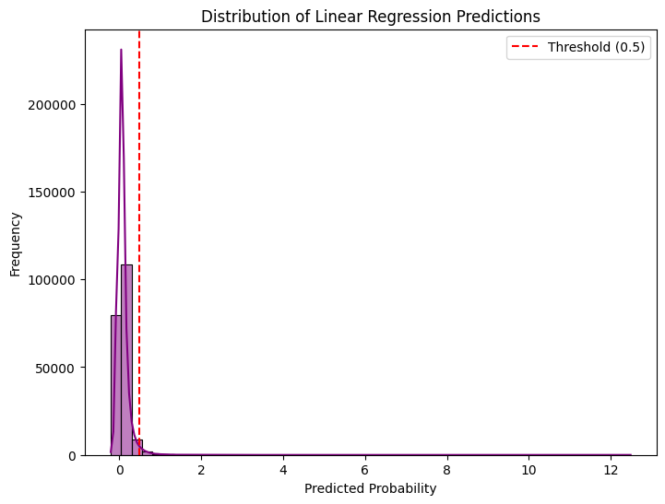
Fig 6.0: Distribution of Linear Regression Predictions
Distribution of Target Variable
The target variable distribution indicates that the dataset is imbalanced, with fewer fraudulent transactions than non-fraudulent ones.
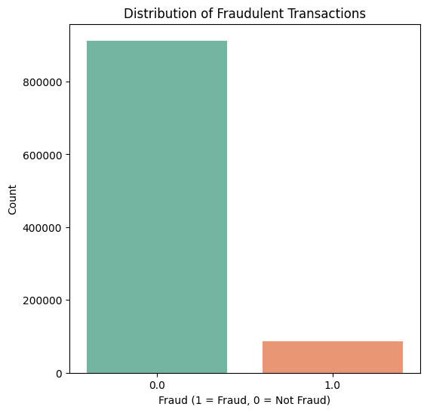
Fig 7.0: Distribution of Target Variable

Boxplots for Numerical Features
Boxplots depict the distribution of numerical attributes for transactions. Fraudulent expenditures generally involve a boxplots below:
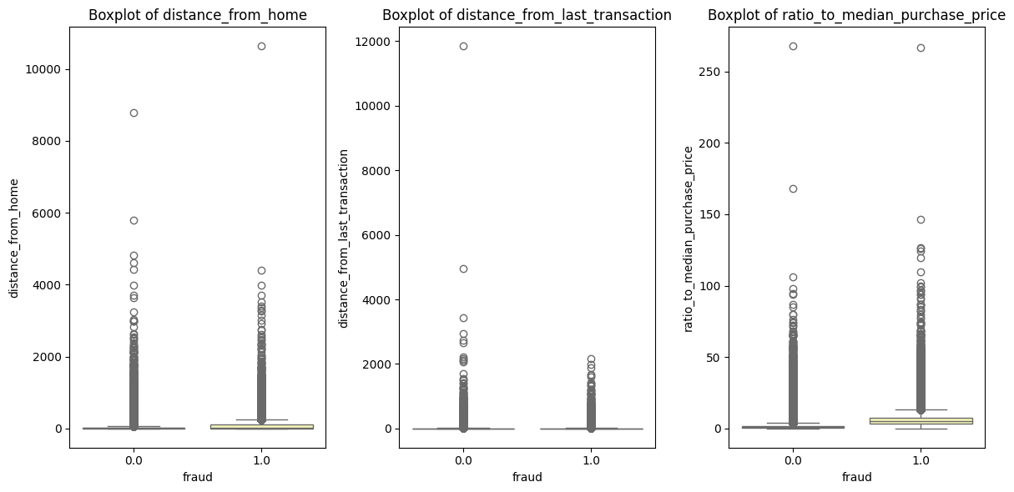
Fig 8.0: Boxplots for numerical features.
ROC Curve Comparison
The ROC curve compares the performance of all models. Decision Tree and KNN achieve higher AUC values than Linear Regression.
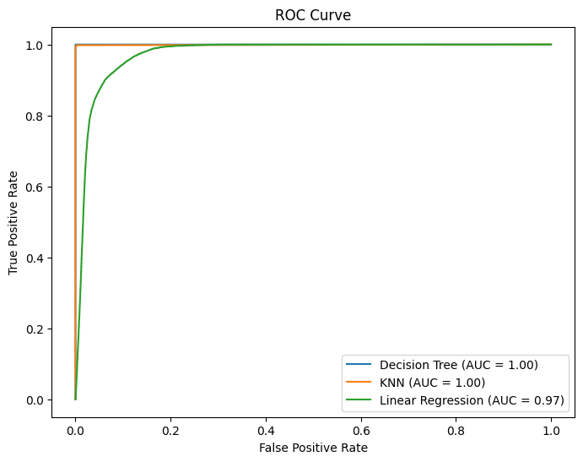
Fig 9.0: ROC Curve for the 3 models

Model Comparison
- Decision Tree: It performs nearly perfect and is therefore the best performing model.
- KNN: Somewhat worse than Decision Tree but still produces very good results.
- Linear Regression: Not appropriate for binary classification, as can be evident from its lower performance measures.
Conclusion
The Decision Tree model is most appropriate for fraud detection and performed best in all metrics. KNN is a viable alternative, but linear regression is not well-suited for this. Visualizations proved helpful in uncovering feature importance, model performance, and data patterns.

